

**Terra Industrial New Zealand Ltd**

PO Box 16 168

16 Branston Street, Hornby

Christchurch 8441, New Zealand

03 983 2333 tel

03 983 5715 fax

www.TerraCat.co.nz



**CUSTOMER DATA STANDARDS**

Customers

Contacts

**Terra Industrial New Zealand Ltd**

PO Box 16 168

16 Branston Street, Hornby

Christchurch 8441, New Zealand

03 983 2333 tel

03 983 5715 fax

www.TerraCat.co.nz

29 JUNE 2020

# Customer Data Standards

TC-CDS-Customers-1.1

## Customers

Data owners:

David Hotham, Greg McCarthy, Chris Heaton

SMEs:

Stephen Frayle, Greg McCarthy, Stuart Thornley

Responsible:

Rental, Power Systems, Sales, Parts & Service reps

e.g. CSAMs, ISRs, TAMs

Not for: Credit controllers

Contents

Customer Data Standards 2

Customers 2

Document History 4

Document information 4

Document amendment history 4

Business Rules: Credit customers 5

Business Rules: Cash Customers 7

Navigation 9

Addresses > Purpose Delivery 10

Contact information 12

Division 14

## Document History

### Document information

|  |  |
| --- | --- |
| Current Version | 1.1 |
| Release Date | 19 June 2020 |
| Document Owner | Jessica Macfarlane |

### Document amendment history

|  |  |  |  |
| --- | --- | --- | --- |
| Version | First Release | Sections(a) Amended | Summary of Amendment |
|  |  |  |  |
|  |  |  |  |
|  |  |  |  |
|  |  |  |  |
|  |  |  |  |

|  |  |  |  |
| --- | --- | --- | --- |
|  |  |  |  |
|  |  |  |  |
|  |  |  |  |
|  |  |  |  |
|  |  |  |  |
|  |  |  |  |

## Business Rules: Credit customers

|  |  |
| --- | --- |
| Rule 1 | The Business ERP (NAXT) must be the "One Source of Truth" for Customer information across the Business |
| Rule 2 | Any Business application containing Customer information must be consistent with NAXT, primarily CRM (SalesLink) |
| Rule 3 | Account numbers must be generated by NAXT and must be unique |
| Rule 4 | Credit accounts must only be created by Credit team for transactional purposes |
| Rule 5 | All account addition requests must be checked in NAXT for potential duplication before creation - NAXT must flag duplicates |
| Rule 6 | Every Customer account must be set up with a primary Division and a primary Industry Code |
| Rule 7 | There must only be 1 Customer account created in NAXT per Customer legal entity (NZBN) for all transactions |
| Rule 8 | Customers operating at multiple sites can have multiple accounts but only 1 account per site with the following naming convention:  "Registered legal name (Site name)" Example: Downer NZ Pty Ltd (Auckland) |
| Rule 9 | Credit limits for each Customer account will be managed by Credit controllers |
| Rule 10 | Only the Credit team must have access to administer Credit Limits for Customers in NAXT - "Credit Limit by Business Area" |
| Rule 11 | Only nominated Marketing Gatekeepers and the Credit team must have access to perform any updates to Customer Master data |
| Rule 12 | All requests to close Customer accounts must be validated and documented with written communication |
| Rule 13 | All Customer accounts to be closed must be deactivated to prevent further transactions - Naming convention must not include "Do Not Use". It should include the current business practice of adding “XXX” to the customer name as a prefix. |
| Rule 14 | When a Customer account is closed, any Equipment records must be transferred to the new Owner account or be made inactive. Only nominated CSC and Marketing Gatekeepers should update Equipment. |
| Rule 15 | Customers transacting online (PCC) must have accounts created in NAXT |
| Rule 16 | NAXT user access levels and system functionality must be in accordance with established Business rules |
| Rule 17 | Data Owners are accountable for adherence to established Data standards and ongoing Data integrity |
| Rule 18 | Nominated SMEs must ensure Business rules and Data standards developed are feasible across all impacted Business areas and work with Data Owners on change management |
| Rule 19 | Retention of Customer records must be in accordance with local regulations |
| Rule 20 | Any changes and exceptions to these rules must be approved by the Data Standards Owner |

## Business Rules: Cash Customers

|  |  |
| --- | --- |
| Rule 1 | The Business ERP (NAXT) must be the "One Source of Truth" for Customer information across the Business |
| Rule 2 | Any Business application containing Customer information must be consistent with NAXT, primarily CRM (SalesLink) |
| Rule 3 | Account numbers must be generated by NAXT and must be unique |
| Rule 4 | Cash Sale accounts must be administered by the nominated cash sale Gatekeepers for transactional purposes |
| Rule 5 | All account addition requests must be checked in NAXT for potential duplication before creation - NAXT must flag duplicates |
| Rule 6 | The following steps must be taken before an account is created:  1. Search in NAXT (ERP) or SalesLink (CRM) if the Customer already exists  2. Ask "Have you purchased from us before?" If yes, utilise existing account. If no, move to step 3 below  3. Ask "Do you intend to purchase from us again?" If yes, encourage a Customer account to be created. If no, use the branch cash sale account |
| Rule 7 | If a Customer account is created, the minimum requirements are Customer name, address, and contact details |
| Rule 8 | Every Customer account must be set up with a primary Division and a primary Industry Code |
| Rule 9 | There must only be 1 Customer account created in NAXT per Customer legal entity (NZBN) for all transactions – If there is already a trade account, a cash sale account must not be created |
| Rule 10 | Customers operating at multiple sites can have multiple accounts but only 1 account per site with the following naming convention:  "Registered legal name (Site name)" Example: Downer and Company Limited (Auckland) |
| Rule 11 | Nominated Marketing Gatekeepers and the Credit team must have access to perform any updates to Customer Master data |
| Rule 12 | All requests to close Customer accounts must be validated and documented with written communication |
| Rule 13 | All Customer accounts to be closed must be deactivated to prevent further transactions - Naming convention must not include "Do Not Use". Closed accounts must have prefix ‘XXX’ added to the customer name field. |
| Rule 14 | When a Customer account is closed, any Equipment records must be transferred to the new Owner account or be made inactive |
| Rule 15 | Customers transacting online (PCC) must have accounts created in NAXT |
| Rule 16 | NAXT user access levels and system functionality must be in accordance with established Business rules |
| Rule 17 | Data Owners are accountable for adherence to established Data standards and ongoing Data integrity |
| Rule 18 | Nominated SMEs must ensure Business rules and Data standards developed are feasible across all impacted Business areas and work with Data Owners on change management |
| Rule 19 | Retention of Customer records must be in accordance with local regulations |
| Rule 20 | Any changes and exceptions to these rules must be approved by the Data Standards Owner |

## Navigation

GGNZ > Sales and Marketing > Common > Customers > All customers

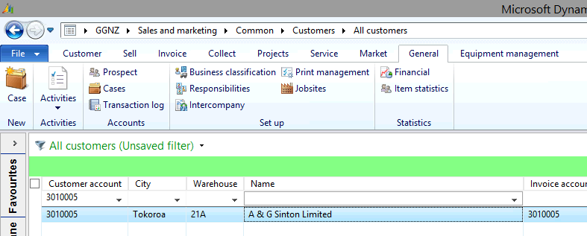

GGNZ > Sales and marketing > Common > Prospects > All prospects

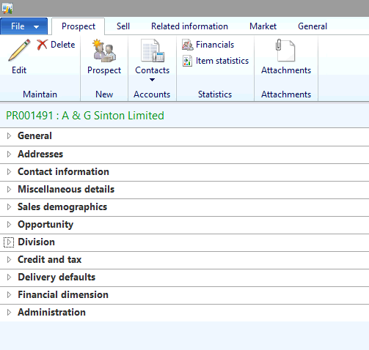

### Addresses > Purpose Delivery

|  |  |  |
| --- | --- | --- |
| **Field** | **Mandatory** | **Data Standard** |
| Name or description | Y | Registered Legal Name - must not include "Do Not Use" |
| Purpose | Y | Defaults to delivery. Credit should be in charge of Purpose "Business". |
| Country | Y |  |
| Post Code | Y | Select from the dropdown. Credit Controllers to add new Postcodes along with associated fields |
| Street | Y | Must not be blank, not to be used for notes |
| City | Y | Populates automatically if Postcode is selected |
| State | Y | Populates automatically if Postcode is selected |

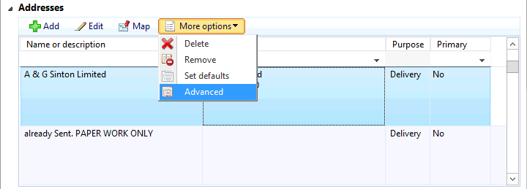

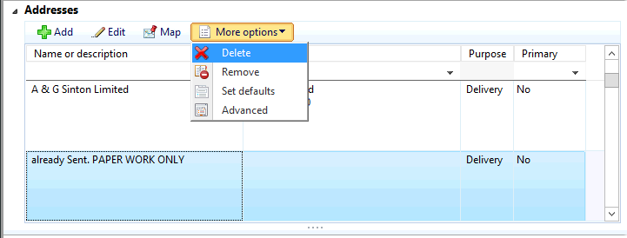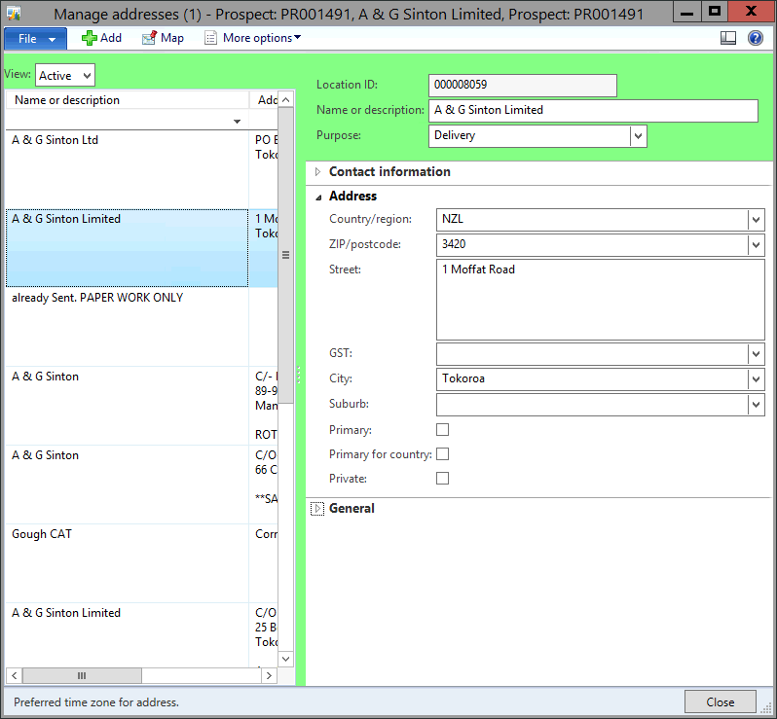

### Contact information

|  |  |  |
| --- | --- | --- |
| **Field** | **Mandatory** | **Data Standard** |
| Type | Y | Phone/E-mail address etc |
| Contact No | Y | Must select 1 Primary check box, New Zealand phone number format including area code - no spaces, no symbols, no notes e.g. 0271234567 or 039876543 |
| Email Address | N | Must select 1 Primary check box |
| Primary check box | N | One primary contact type must be selected per customer account |
| Mobile check box | N | Required for every mobile number on account |

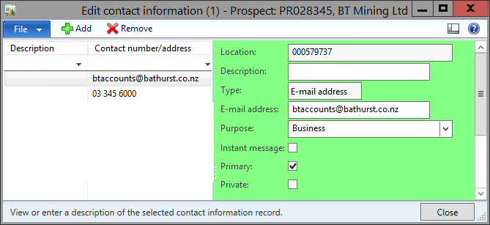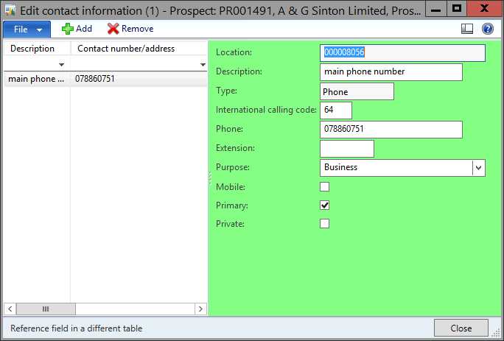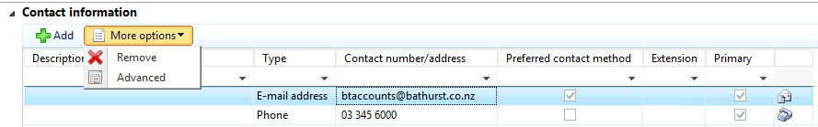

### Division

|  |  |  |
| --- | --- | --- |
| **Field** | **Mandatory** | **Data Standard** |
| Division | Y | Select your division e.g. EPT, EEQ, EPS. Remove legacy or unused divisions e.g. TWL, EEN, ETR |
| Primary Division | N | Only one Division must be selected - Primary checkbox ticked. It's associated Industry code will represent the customer's main industry. |
| Industry Code | Y | Each division must have an associated industry code populated. E.g. select both SIC and CIC codes. |
| Primary Industry Code | N | More than one Industry Code may be populated; however, the Primary checkbox must be selected only once |

